Chapter 8-[Functions and one-to-one](https://mfleck.cs.illinois.edu/building-blocks/version-1.3/functions-one-to-one.pdf)

Friday, December 30, 2022

6:56 PM

***One-to-One:***

A function is one-to-one if it never assigns two input values to the same output value.



Or the contrapositive (more useful definition):



***Bijection/Bijective:***

A function that is both one-to-one and onto.



An *onto* function from A to B requires that A have at least as many elements as B;

A *one-to-one* function from A to B requires that B have at least as many values as A;

So, if there is a *bijection* between A and B, then the two sets must contain the **same number of elements**.

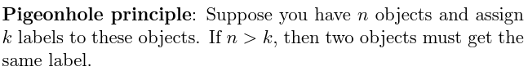

(sometimes can be used as a clever trick in a proof that seems unrelated)

*(or just include it in a random proof for fun if you want)*

***Permutations:***

An arrangement of n objects in order.

(For example, there is set A and set B with the same size n, there are many ways to construct a one-to-one function using A and B. After choosing the output for each input, there will be 1 less output to choose from for the following inputs, so the total number of ways is n!)

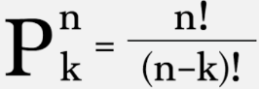

(where n is the total number of objects available to choose from, and k is the number of objects we need to choose)

***Proving a Function is One-to-One:***

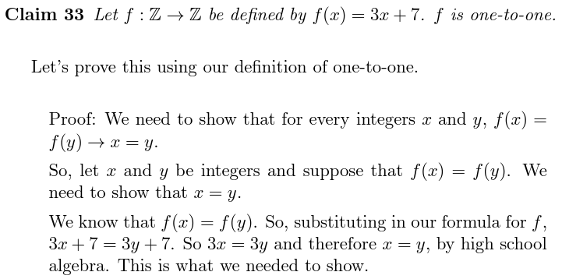

***One-to-One Composition:***



